Island status and trends
This section summarizes SPC data collected at each island between 2010 and 2024, when comparable methods were used. For each island within a region, maps illustrate the SPC site-level data, and a standard set of graphs shows summary information on the fish community at the island scale for each year there was sufficient sampling. On each fish biomass graph for the forereef habitat, a reference line indicates the region-wide mean estimate across all surveyed years (2010–2024), provided as a relevant regional comparison for island-level estimates. Fish biomass estimates are shown for each year of all fish combined, all fish in two size classes, parrotfish in two size classes, species of interest, and by consumer group. All fish, consumer group, and parrotfish biomass are core NCRMP indicators (NOAA CRCP 2014). Large parrotfishes are important grazers, so parrotfish biomass is separately reported for two size groups: large (> 30 cm TL) and small (10–30 cm TL) fishes. Mean fish size (cm TL) per island and year is also reported, as it can be a useful indicator of fishing pressure; fishes smaller than 10 cm TL are excluded to reduce noise from variable levels of recent fish recruitment. Biomass for jacks and all shark species are also shown.

Hawai‘i
Table 2: Year surveyed and number of sites
Year | Sites
2010 | 43
2013 | 58
2015 | 97
2016 | 59
2019 | 73
2024 | 47

Hawai‘i is further broken down into geographic sectors due to its large size. Sectors are indicated by different colors on the map and summary data are shown at the island level as well as the sector level. Not all sectors were able to be surveyed each year.
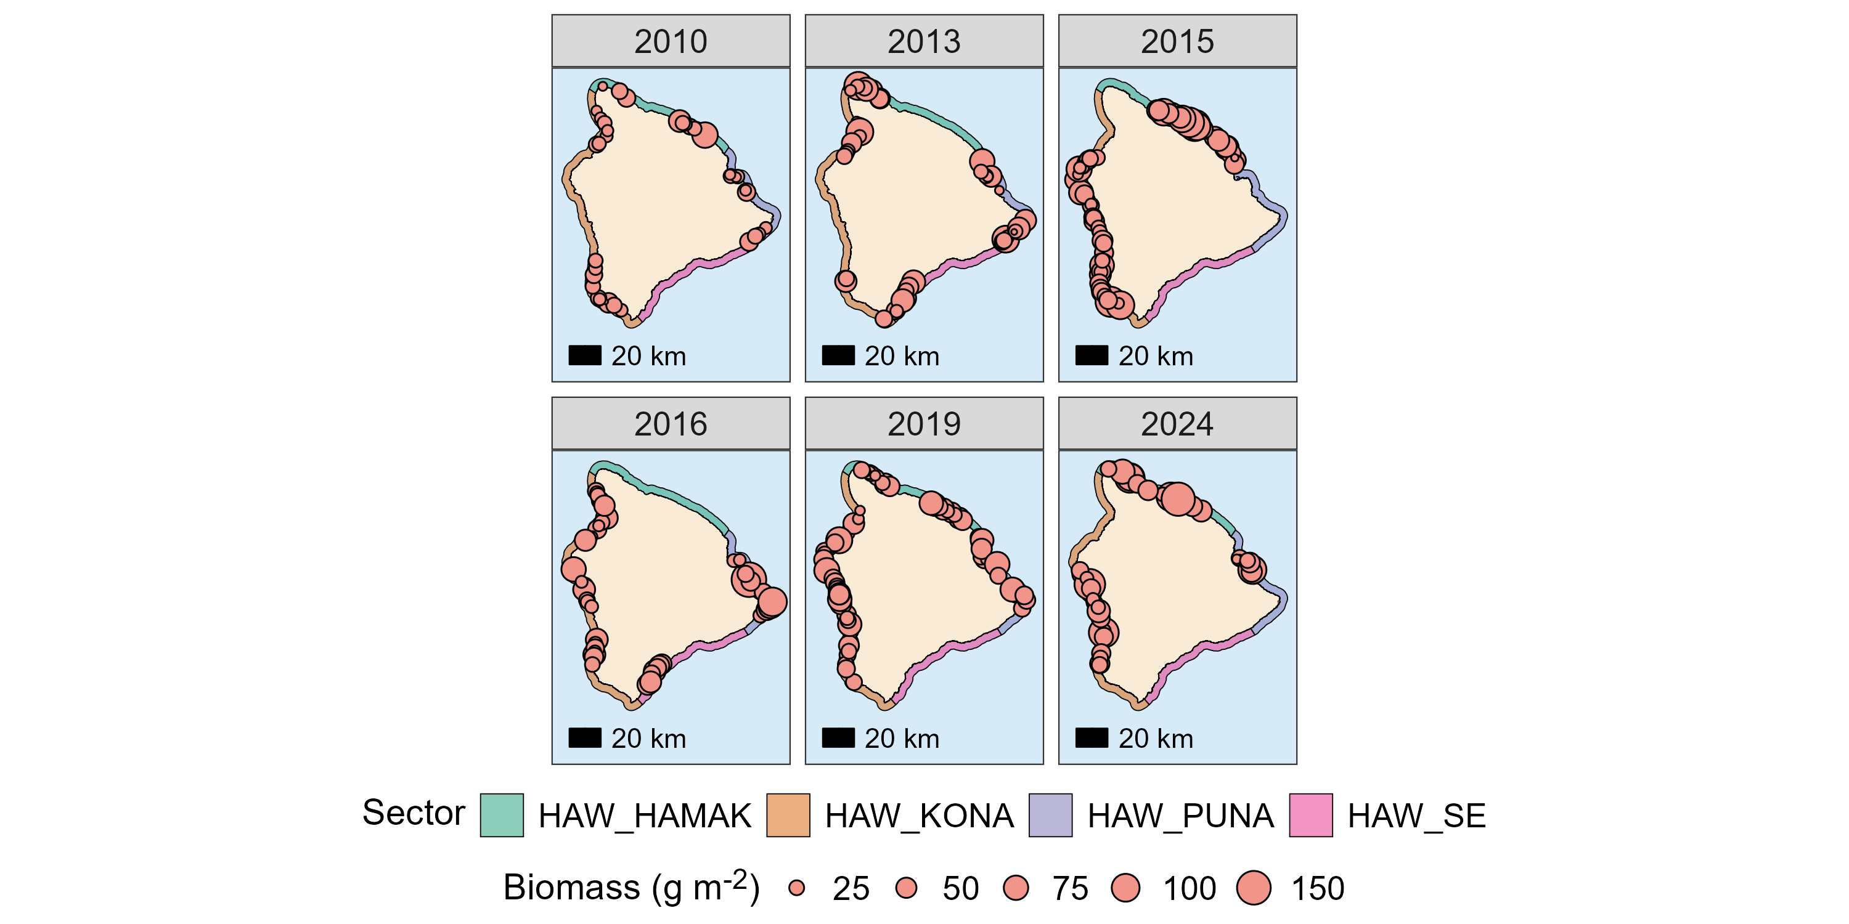
Figure 5: Hawai‘i Island site survey data by year. Each bubble represents a survey site and the size of the bubble corresponds to total fish biomass at each site.
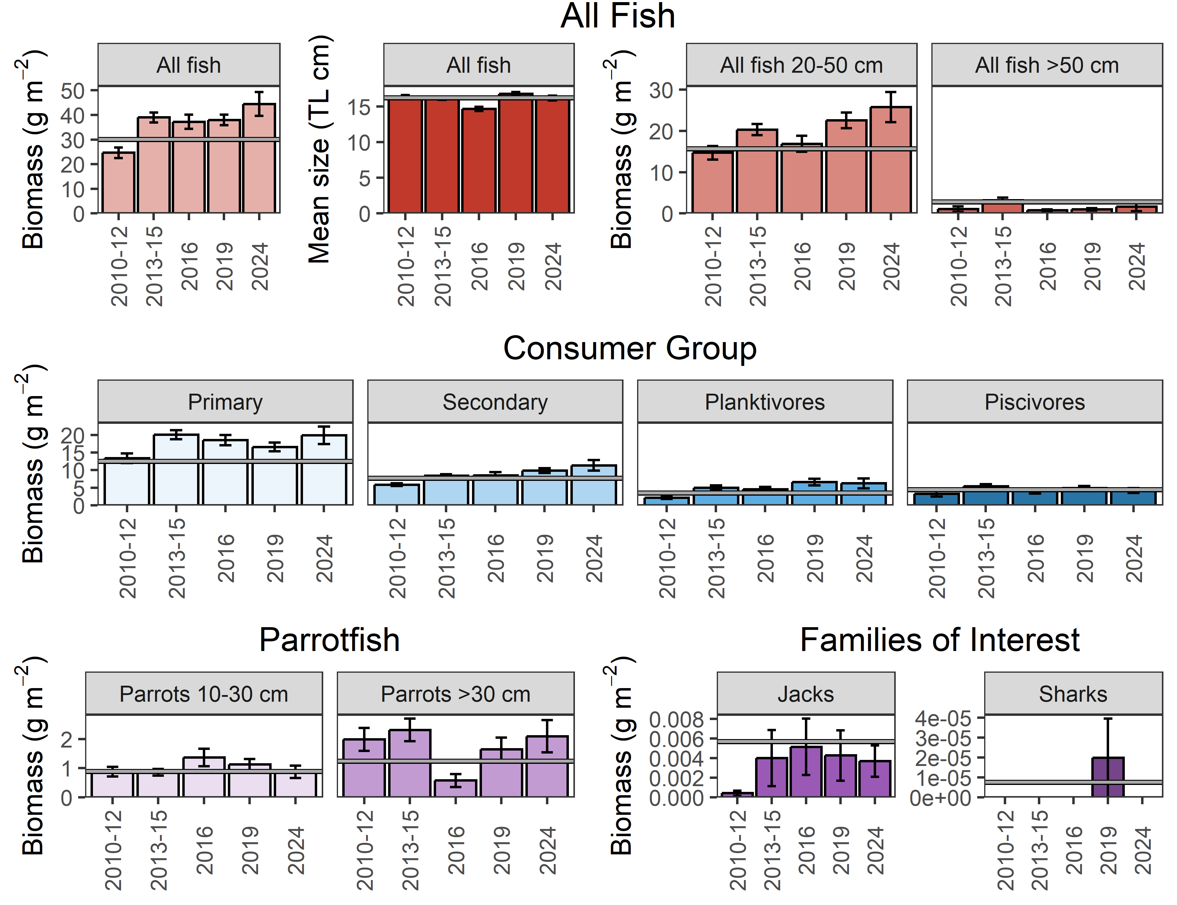
Figure 6: Hawai‘i Island fish plots. Mean values ± standard error are plotted for biomass, mean size, and biomass per size class of all fishes observed (top); as well as biomass per consumer group (middle), parrotfish size classes (bottom left), and species of interest (bottom right). The Hawai`i regional mean estimates of each metric are plotted for reference (horizontal grey line).

Hawai‘i’s Hamakua Sector, indicated by green (Figure 5).
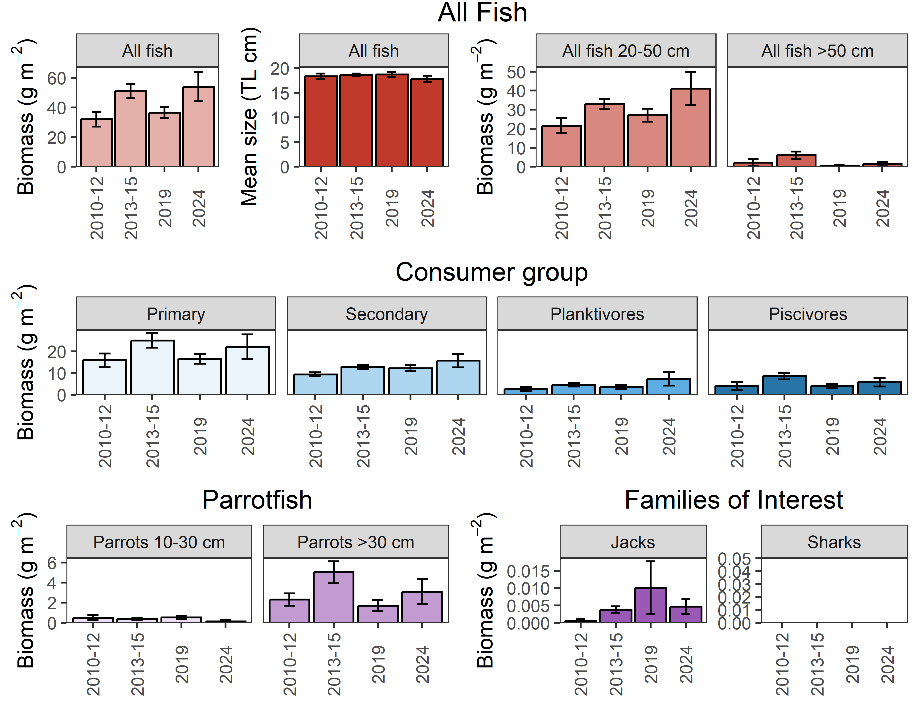
Figure 7: Hawai‘i Island sector fish plots. Mean values ± standard error are plotted for biomass, mean size, and biomass per size class of all fishes observed (top); as well as biomass per consumer group (middle), parrotfish size classes (bottom left), and species of interest (bottom right).
Hawai‘i’s Kona Sector, indicated by orange (Figure 5).
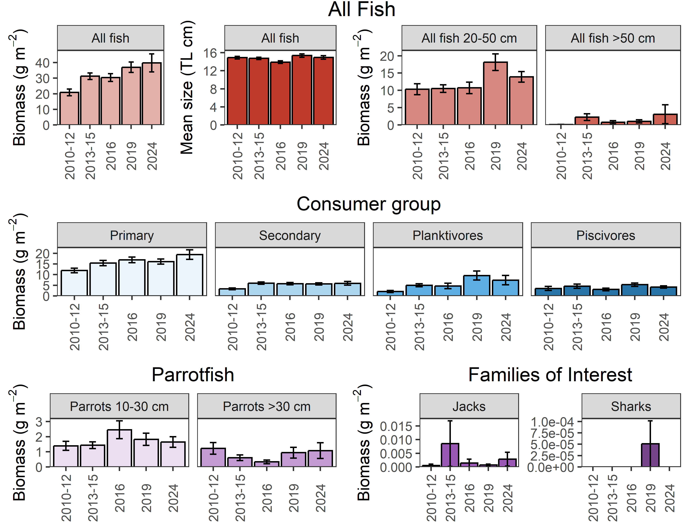
Figure 8: Hawai‘i Island sector fish plots. Mean values ± standard error are plotted for biomass, mean size, and biomass per size class of all fishes observed (top); as well as biomass per consumer group (middle), parrotfish size classes (bottom left), and species of interest (bottom right).

Hawai‘i’s Puna Sector, indicated by purple (Figure 5).

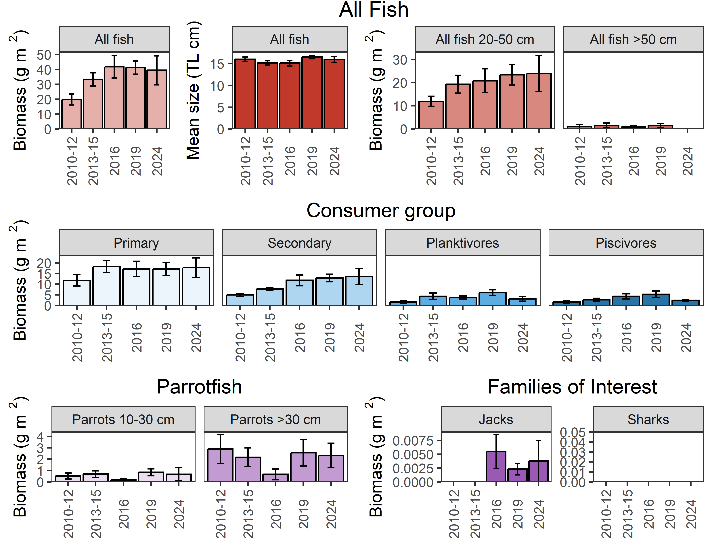
Figure 9: Hawai‘i Island sector fish plots. Mean values ± standard error are plotted for biomass, mean size, and biomass per size class of all fishes observed (top); as well as biomass per consumer group (middle), parrotfish size classes (bottom left), and species of interest (bottom right).

Hawai‘i’s Southeast Sector, indicated by pink (Figure 5).

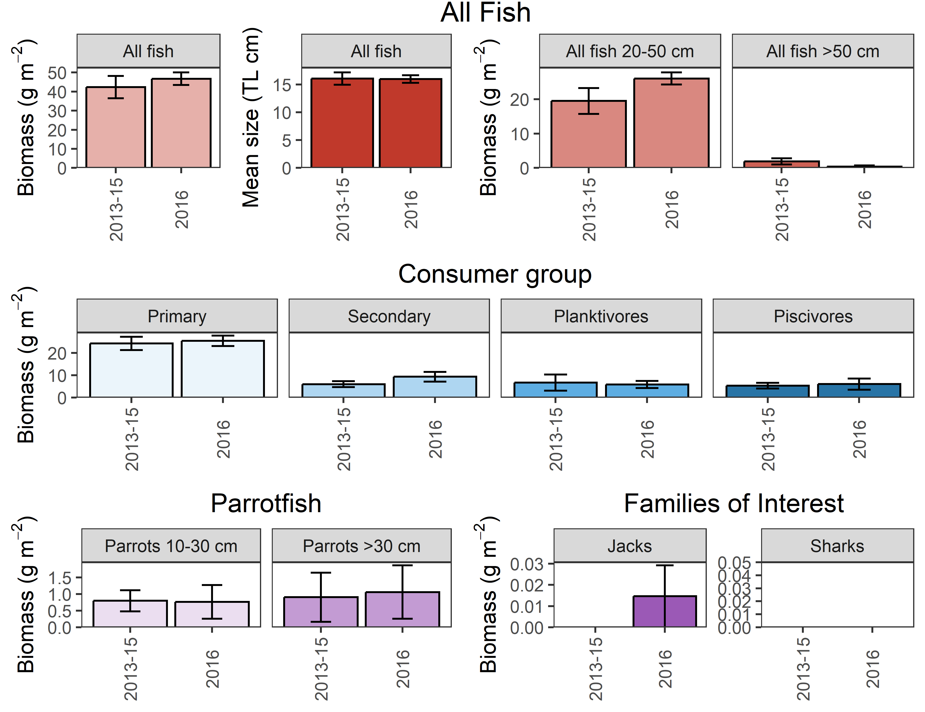
Figure 10: Hawai‘i Island sector fish plots. Mean values ± standard error are plotted for biomass, mean size, and biomass per size class of all fishes observed (top); as well as biomass per consumer group (middle), parrotfish size classes (bottom left), and species of interest (bottom right).

